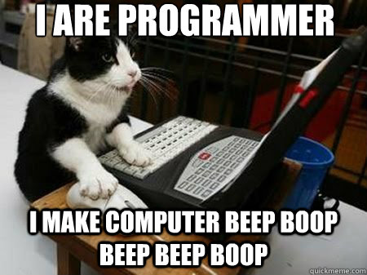
Lab 1: Introduction to Kinematics and Vpython

Overview:
This is going to be your first part of a six part series of programming labs that you will be required to complete throughout the year. The aim of these labs are to reinforce many of the concepts we will learn in the first six months of our course in addition to you gaining programming experience.

These labs will be graded primarily on effort so do not worry about arriving at the correct answer (you will still need to meet a few minimum standards). Participation in these labs will account for 80% of your grade and the other 20% of your grade will be derived from your results. Disclaimer: We will be working on programming once a week in class so I can monitor your progress and help if you get stuck. If you are not making an effort to write your program, you will be penalized on your final lab grade.

Each lab will be conducted over four weeks and you will be required to have access to a computer that you can install software on. If you cannot access a computer at home for this project, please see me privately so I can make accommodations.

Cheating and dishonesty will not really apply to these labs as I will encourage you all to work together and to use online resources. The last lab will require extensive programming and it is in your best interest to be proactive in these assignments. If I notice that you are just copy and pasting all your lab work rather than trying to work on it yourself, I will quiz you on your code. The quiz will count towards your lab grade.

Lastly, have fun! These labs are meant to be more of a side project that enriches your STEM tool kit. Programming can be very rewarding when you see your own creation compile and run correctly. So, now that we have our introduction out of the way, lets move on to getting started.

Part 1: Getting started.
Before we can begin actually programming, we need to install our programming environment. In addition to our environment, we have to install the Vpython Package. The first step in doing this will be to install Anaconda. Follow this link to download the installer:

http://continuum.io/downloads

After downloading the installer, run the install wizard. This process may take some time. After this program is installed, you can launch anaconda and launch the spyder app. This will be the window where you do all your programming. The left hand window is where you write your code and the right hand window is your python console that will act as your standard output. Lets move on to download Vpython. You will need to open your command prompt window. Go to your computer's start menu and search cmd, this should automatically open your command prompt. The window looks like this:

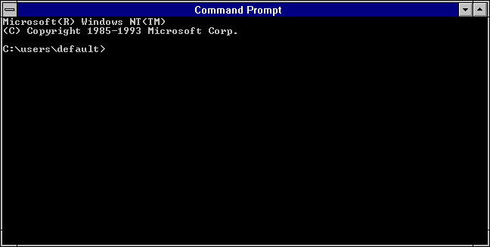

Once you have this window open, type the following into it:

conda install -c https://conda.binstar.org/mwcraig vpython

Doing that should automatically add vPython to spyder. After this is done, we should be ready to program any of the six labs ahead of us.

Part 2: Tutorial
Now that we are ready to program, launch spyder and follow this link to a series of YouTube videos: Youtube. If you are not accessing this document electronically, you can find the video series by searching YouTube for DrDash followed by clicking on her vPython introduction series. The first part of this lab is to reinforce our in-class demo with programming. I want you to watch the first two videos and provide a 1-paragraph summary to each video. Highlight any rules and tips in your summary as well as any important syntax information.

After watching the videos, you should move on to write your own program now. Write a program that will result in an output of "hello world!." Start by opening a new file and saving it as Lab1Part2. There should be a header consisting of the following on the next page:

"""
Created on Sat May 23 16:48:20 2015
In this area you should write a description of your program. Keep the description short and sweet!
@author: Catz Iz Best
"""
You should write a brief description of your program in the header as I have highlighted above. Next, you should write a print statement. It should look something like this:

print ""

Print is a built in function for python and it's reserved by the environment to be used only for printing to the standard output (your console window). The quotations above signal the program that plain text is contained within the quotes. The program will print any words (even reserved words) contained within those quotations. Lastly, if you want to print more than one object, just use commas separating each object that you want to print. Now use this information to write the "hello world" program.

For the last part of the tutorial, we will talk about variables. Variables are usually letters or words that you assign data to. For example, x = 3.0, is read as x is assigned the value of 3.0. You can also assign text, known as a string, to variables. For example, x = "hello world" is a valid assignment to x. Try rewriting your "hello world" program to print a variable instead of the direct text. Use the following code below as a guide:

x = "hello "
y = "world"
z = "!"

print x, y, z

You can write multiple objects in front of your print statement as long as they are separated by commas. You can even combine variables and text in your print statement! Try the code below out

x = "hello,"
y = "student"
print x, "it's nice to meet you", y

Lastly, you can assign variables to take in input from your console using the input function:
input("Text goes here for a standard output. This can be some sort of instructions to the user.")
Try using the code below and play around with it to see how you can change the input and output.

x = input("Please input a value to be printed: ")
x = x + 1
print x
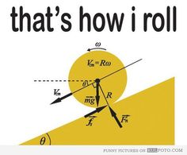

Part 3: Kinematics Program
This is the primary program you will write for this lab. Based off of some of the kinematic equations we have gone over in class, I want you to write a calculator for solving 1-d kinematic programs. The equations you will be working with are the following:

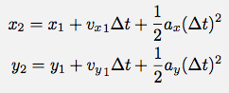
Using your notes from our programming demo and the YouTube videos as your resource, I want you to write a program that takes in the input for initial position, initial velocity, acceleration, and travel time, and returns the final position of the object. Your objectives are outlined below, have fun and good luck!

- Code a kinematic equation
- Take in inputs for:
  - initial position
  - initial velocity
  - acceleration
  - travel time
- Output the final position

Save the file as lab1part3 and keep it in your master lab folder. I will check your programs during our lab in-class.

